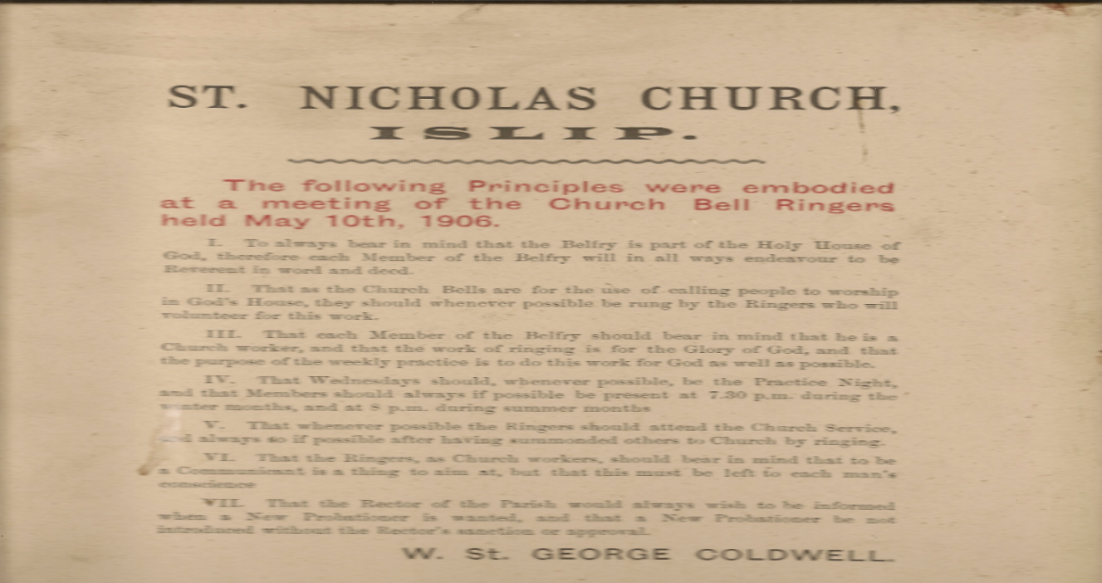
Date |  |  |  |  | Date
1892 | Fredrk William Knight |  |  |  | 1909 | Alfred G. Knight
1892 | Thomas S. Dyutten |  |  |  | left 1910 | Thomas Simms |  | left
1893 | R. E. Loveday |  |  |  | 1911 | James Slattter |  | 1912
1893 | G. Hewitt left 1916 |  |  |  | 1912 | H. Percy Knighton
 |  |  |  |  |  | Fallen on the Great War Oct 3 1915
1898 | W. Knighton
 |  |  |  |  | 1919 | George James Knighton
1900 | E. Curtis
 |  |  |  |  | 1919 | Charles Henry Steward
1903 | T. Jervis
 |  |  |  |  | 1919 | Noah Dicks
1906 | A. Johnson left 1912
1906 | E. Day
1909 | B. C. Loveday
 | Missing in the Gt War March 1918

